**BTS USER MANUAL**

**1. One day trip – BT Approval 2**

**1. Object 2**

**2. Purpose 2**

**3. Screen 2**

**4. Functions 2**

**2. One day trip – BT Expense Declaration 7**

**1. Object 7**

**2. Purpose 8**

**3. Screen 8**

**4. Functions 8**

**3. Over night trip – BT Approval 14**

**1. Object 14**

**2. Purpose 14**

**3. Screen 14**

**4. Functions 15**

**4. Overnight trip – BT Expense Declaration 20**

**1. Object 20**

**2. Purpose 20**

**3. Screen 20**

**4. Functions 21**

# 1. One day trip – BT Approval

1. **Object**

* Employee or Timekeeper

1. **Purpose**

* View/ Create/ Edit advanced request of one day business trip.
* Find history of advanced request of one day business trip.
* In time update information to related functions (ADM, Finance) to process documents

1. **Screen**

**Function access:** One day trip/ BT Approval

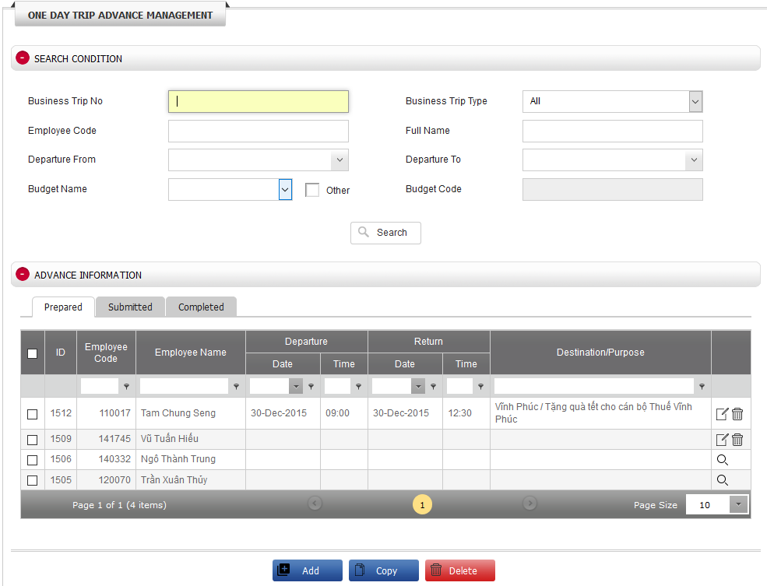

1. **Functions**

***4.1: Search***

* ***Purpose:***
* Find history of advanced request of one day business trip.
* ***Step to do:***
* In the screen of ONE DAY TRIP ADVANCE MANAGEMENT, input 1 or more coditions in ‘SEARCH CONDITION’
* Business Trip No: input data
* Business Trip Type: select ‘One day trip’
* Employee Code: input data
* Full Name: full name of employee in advanced request
* Departure From: Departure date
* Departure To: Departure date
* Budget Name: select one of the list. Default list consists of budget code belongs to employee’s department only.
  + Tick to Other box to show all company budget codes
* Click **[Search]**
* ***Result:***
* All advanced requests of one day business trip satisfied with inputting conditions will be showed under ‘ADVANCE INFORMATION’.
* The result will be showed in 3 tabs : Prepared, Submitted, Completed as the below statuses:
  + Prepared tab: consist of all advanced requests which are newly created and not submitted yet.
  + Submitted tab: consist of all advanced requests which are already submitted.
  + Completed tab: consist of all advanced requests which are successfully created on finance system (Finance Dept. completely processed your request)

***4.2: Create new advanced request***

* ***Purpose:***
* Create new advanced request of one day business trip
* Export information to correct template according to company policy: Business Trip Approval (One Day Trip)
* Submit to Finance Budget for checking Budget code purpose.
* ***Step to do:***
* In the screen of ‘ONE DAY TRIP ADVANCE MANAGEMENT’, click **[Add]** located at below of screen.
* Input data to the screen of ‘Input BT Information’

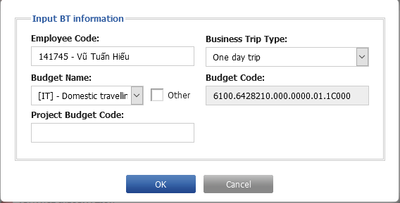

* + Employee Code.
  + Business Trip Type.
  + Budget Name: Default list consists of budget code belongs to employee’s department only. In order to show all budget names of company’s budget code, just tick to Other check box.
  + Project Budget Code: Budget code for project
* Click **[OK]** to go to another screen to input more detailed for business trip
* Click header of ‘ADVANCE REQUEST’ to expand hidden information & then click **[Add]** to input expense and click **[Save]** after inputting completed.
  + Date: business trip date
  + Time: business trip time
  + Destination: business trip province/city
  + Moving Time Allowance.
  + Meal: meal allowance is auto calculated based on company policy
    - Times: number of having breakfast, lunch, dinner.
    - Unit: allowance per day.
    - Amount: Total allowance amount.
  + Transportation
    - Times: number of using transportation: Taxi/ Car, Motorbike
    - Estimate Fee: Total estimated amount of using Transportation: Taxi/Car, Motorbike
  + Company Car Request: tick if request GA to arrange company car
  + Purpose: if your business trip is for a project or an event, you need to specify what project or event name. E.g. Project XXX or support project XXX of ABC department.
  + Request Date.
* Click **[Save]** located at below of screen to save all data
* Click [**Export BT request**] to export to Business trip approval form



* Click header of ‘ATTACHMENT’ to expand hidden information & then click **[Choose file]** to upload forms related to the business trip
  + Business Trip Approval
  + Others: other forms
* Click **[Submit]** to send request to Finance Budget or click **[Cancel]** to cancel & close current screen.
* ***Result:***
* All data on screen will be saved after clicking **[Save]** and submit to Finance Budget after clicking **[Submit]**
* Business Trip Number will be generated after clicking **[Save]**:

Business Trip Number is formatted as following:

* “Company branch code”S-“Employee code”-DDMMYY-XXX
* More details:
  + Company branch code: HQ (Head quarter), HN (Ha Noi Branch), HM (Ho Chi Minh Branch), TRN (Ha Noi Training Center), TSC (Toyota South Center)
  + Employee code: Employee code in current business trip
  + DDMMYY: Date generated after submitted successfully
  + XXX: sequence number increase automatically. Reset to 0 after over 999.
* After submitted successfully, that advanced request will be showed at Submitted tab

***4.3: Modify advanced request***

* ***Purpose:***
* Modify advanced request of one day business trip, that is not yet submitted to Finance Budget
* Export to BT approval (one day trip) form after completed modifying data
* Resubmit to Finance Budget for checking Budget Code purpose
* ***Step to do:***
* Search for the last business trip in ‘SEARCH CONDITION’
* In ‘ADVANCE INFORMATION’, click Edit icon of business trip that need to modify



* In ‘ADVANCE REQUEST’, click Edit icon of record that need to modify.



* + Correct business trip information and then click **[Save]** to save all information that has just been changed.
* Click **[Save]** located at the bottom of screen to save all information
* Click [**Export BT request**] to export BT Approval form



* In ‘ATTACHMENT’, click **[Choose file]** to upload forms related to the business trip
* Click **[Submit]** to submit request to Finance Budget or click **[Cancel]** to cancel and close current screen.
* ***Result:***
* All data on screen will be saved after clicking **[Save]** and submit to Finance Budget after clicking **[Submit]**
* Business Trip Number will be generated after clicking **[Save]:**

Business Trip Number is formatted as following:

* “Company branch code”S-“Employee code”-DDMMYY-XXX
* More details:
  + Company branch code: HQ (Head quarter), HN (Ha Noi Branch), HM (Ho Chi Minh Branch), TRN (Ha Noi Training Center), TSC (Toyota South Center)
  + Employee code: Employee code in current business trip
  + DDMMYY: Date generated after submitted successfully
  + XXX: sequence number increase automatically. Reset to 0 after over 999
* After submitted successfully, that advanced request will be showed at Submitted tab.

***4.4: Copy business trip as a template to other person(s)***

* ***Purpose:***
* Copy as a template all advanced request information of one day business trip from employee to other(s)
* ***Step to do:***
* In screen of ‘ONE DAY TRIP ADVANCE MANAGEMENT’, select an advanced request that needs to copy as a template by ticking in checkbox at the beginning of record and click **[Copy]** located at the bottom of screen.

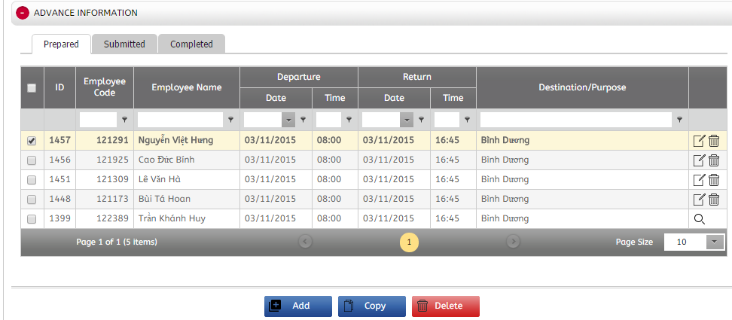

* Select employee(s) whose advanced request needed to copy as a template by ticking in the checkbox at the beginning of employee record in screen of ‘Choose Employees’ and click **[Copy]**

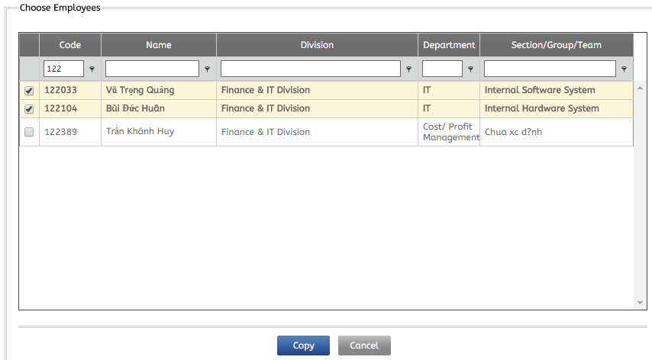

* ***Result:***
* After copied as template to other employee(s), new advanced request(s) will be cloned and showed in ‘ADVANCE INFORMATION’ in screen of ‘ONE DAY TRIP ADVANCE MANAGEMENT’

***4.5: Delete advanced request***

* ***Purpose:***
* Delete advanced request of one day business trip.
* ***Step to do:***
* Search for the last business trip in ‘SEARCH CONDITION’
* In ‘ADVANCE INFORMATION’, click dustbin icon to delete advanced request that no need to use anymore.



* Alternately, can do multi-deletion by ticking more than one advanced request and click **[Delete]** located at the botton of screen.
* ***Result:***
* After deletion, advanced request(s) is/are deleted from system

# 2. One day trip – BT Expense Declaration

1. **Object**

* Employee or Timekeeper

1. **Purpose**

* Find history of expense request of one day business trip
* View/ Create/ Modify exepense request of one day business trip

1. **Screen**

**Function access:** One day trip/ BT Expense Declaration

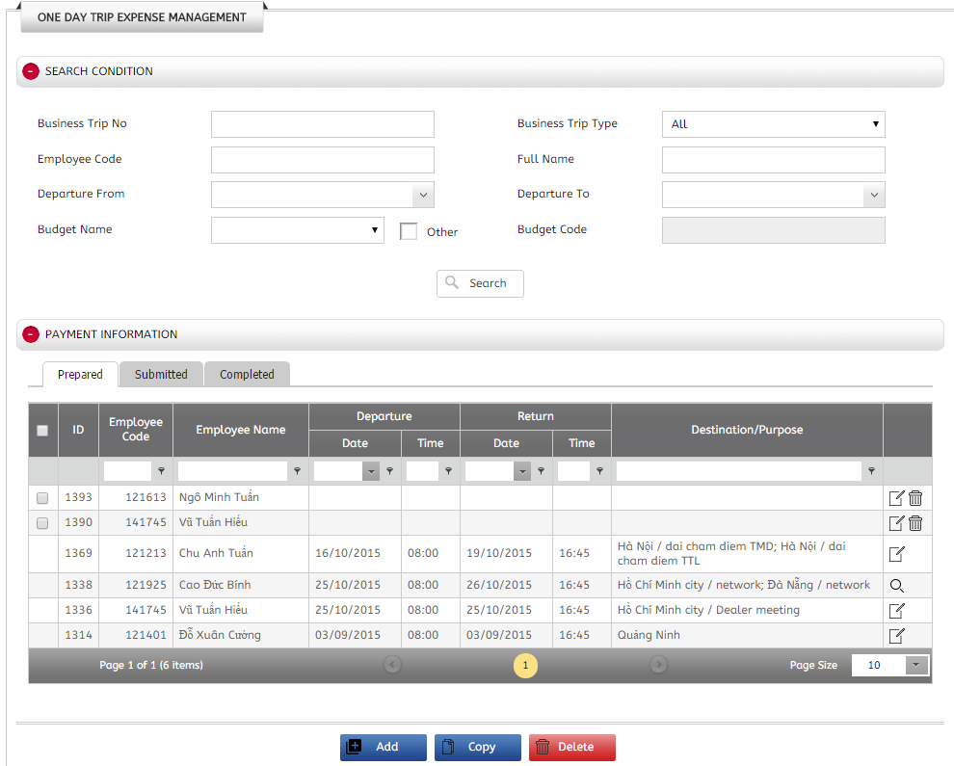

1. **Functions**

***4.1: Search***

* ***Purpose:***
* Find history of expense request of one day business trip
* ***Step to do:***
* In screen of ONE DAY TRIP EXPENSE MANAGEMENT, input condition(s) in ‘SEARCH CONDITION’
* Business Trip No
* Business Trip Type.
* Employee Code.
* Full Name: full name of employee in expense request.
* Departure From: Departure Date
* Departure To: Departure Date
* Budget Name: Default list consists of budget code belongs to employee’s department only. In order to show all budget names of company’s budget code, just tick to Other check box
  + Tick to Other box to show all company budget codes
* Click **[Search]**
* ***Result:***
* All advanced requests of one day business trip satisfied with inputting conditions will be showed under ‘EXPENSE INFORMATION’
* The result will be showed in 3 tabs : Prepared, Submitted, Completed as the below statuses
  + Prepared tab: consist of all expense requests which are newly created and not submitted yet.
  + Submitted tab: consist of all expense requests which are already submitted
  + Completed tab: consist of all expense requests which are successfully created on finance system (Finance Dept. completely processed your request)

***4.2: Create new expense request***

* ***Purpose:***
* Create new expense request of one day business trip
* Export information to correct template according to company policy: Business Trip Expense Declaration
* Submit to Finance Budget for checking Budget code purpose
* ***Step to do:***

***Method 1: for employees who do not request advanced requests***

* In screen of ‘ONE DAY TRIP EXPENSE MANAGEMENT’, click **[Add]** located at the bottom of screen
* Input data to the screen of ‘Input BT Information’
  + Employee Code
  + Business Trip Type
  + Budget Name
  + Project Budget Code
* Click **[OK]**
* In ‘PAYMENT REQUEST’, click **[Add]** to input expense information and click **[Save]** after inputting data completed.
  + Date: Business trip date
  + Time: Business trip time
  + Destination: Business trip city
  + Moving Time Allowance.
  + Meal: meal allowance is auto calculated based on company policy
    - Times: number of having breakfast, lunch, dinner
    - Unit: allowance per day
    - Amount: Total allowance amount
  + Transportation
    - Times: number of using transportation: Taxi/ Car, Motorbike
    - Estimate Fee: Total estimated amount of using Transportation: Taxi/Car, Motorbike
  + Company Car Request: Tick if request GA to arrange company car
  + Purpose: If your business trip is for a project or an event, you need to specify what project or event name. E.g. Project XXX or support project XXX of ABC department
  + Request Date: Date of request
* In ‘ATTACHMENT’, click **[Choose file]** to upload forms related to the business trip
  + Request for Payment: attach Business trip expense delaration form
  + Others: other forms
* Click **[Save]** located under screen of ‘ONE DAY TRIP EXPENSE MANAGEMENT’ to save all information
* Click **[Submit]** to send expense request to Finance Budget or click **[Cancel]** to cancel & close screen of ‘ONE DAY TRIP EXPENSE MANAGEMENT’.
* ***Result:***
* All data on screen will be saved after clicking **[Save]** and submit to Finance Budget after clicking **[Submit]**
* Business Trip Number will be generated after clicking **[Save]**:

Business Trip Number is formatted as following:

* “Company branch code”S-“Employee code”-DDMMYY-XXX
* More details:
  + Company branch code: HQ (Head quarter), HN (Ha Noi Branch), HM (Ho Chi Minh Branch), TRN (Ha Noi Training Center), TSC (Toyota South Center)
  + Employee code: Employee code in current business trip
  + DDMMYY: Date generated after submitted successfully
  + XXX: sequence number increase automatically. Reset to 0 after over 999
* After submitted successfully, that advanced request will be showed at Submitted tab

***Method 2: for employees who requested advanced requests before.***

* In screen of ‘ONE DAY TRIP EXPENSE MANAGEMENT’, find advanced requests that were created in system previously & click Edit icon



* Based on actual expense, modify all information in screen of ‘ONE DAY TRIP EXPENSE MANAGEMENT’
* In ‘PAYMENT REQUEST’, go to ‘Common’ tab and click **[Add]** to input expense information and click **[Save]** after inputting data completed.
  + Date: business trip date
  + Time: business trip time
  + Destination: business trip province/city
  + Moving Time Allowance
  + Meal: meal allowance is auto calculated based on company policy
    - Times: Number of having breakfast, lunch, dinner
    - Unit: Allowance per day
    - Amount: Total allowance amount
  + Transportation
    - Times: Number of using transportation: Taxi/ Car, Motorbike
    - Estimate Fee: Total amount of using Transportation: Taxi/Car, Motorbike
  + Company Car Request: Tick if request GA to arrange company car
  + Purpose: If your business trip is for a project or an event, you need to specify what project or event name. E.g. Project XXX or support project XXX of ABC department
  + Request Date: Date of request
* Click **[Save]** located at the bottom screen of ‘ONE DAY TRIP EXPENSE MANAGEMENT’ to save all information
* Click **[Export Request for Payment]** to export to Business trip expense declaration



* In ‘ATTACHMENT’, click **[Choose file]** to upload forms related to the business trip
  + Request for Payment: attach Business trip expense declaration
  + Others: other forms
* Click **[Submit]** to send expense request to Finance Budget or click **[Cancel]** to cancel & close screen of ‘ONE DAY TRIP EXPENSE MANAGEMENT’.
* ***Result:***
* All data on screen will be saved after clicking **[Save]** and submit to Finance after clicking **[Submit]**
* Business Trip Number of expense request is the same as Number of Advanced request
* After submitted successfully, that advanced request will be showed at Submitted tab

***4.3: Modify expense request***

* ***Purpose:***
* Modify expense request of one day business trip, that is not yet submitted to Finance
* Export to Business Trip Expense Declaration form after completed modifying data
* Submit to Finance Budget for checking Budget code purpose
* ***Step to do:***
* Search for the last business trip in ‘SEARCH CONDITION’
* In ‘PAYMENT INFORMATION’, click Edit icon of business trip that need to modify



* Correct business trip information an screen of ‘ONE DAY TRIP EXPENSE MANAGEMENT’’
* In ‘PAYMENT REQUEST’, click Edit icon of record that need to modify.



* + Correct business trip information and then click **[Save]** to save all information that has just been changed.
* Click **[Save]** located at the bottom of screen to save all information
* Click **[Export Request for Payment]** to export Business Trip Expense Declaration form



* In ‘ATTACHMENT’, click **[Choose file]** to upload forms related to the business trip
* Click **[Submit]** to send to Finance Budget or click **[Cancel]** to cancel and close current screen
* ***Result:***
* All data on screen will be saved after clicking **[Save]** and submit to Finance Budget after clicking **[Submit]**
* After submitted successfully, that advanced request will be showed at Submitted tab.

***4.4: Copy business trip as template to other person(s)***

* ***Purpose:***
* Copy as a template all expense request information of one day business trip from employee to other(s)
* ***Step to do:***
* In screen of ‘ONE DAY TRIP EXPENSE MANAGEMENT’, select an expense request that needs to copy as a template by ticking in checkbox at the beginning of record and click **[Copy]** located at the bottom of screen

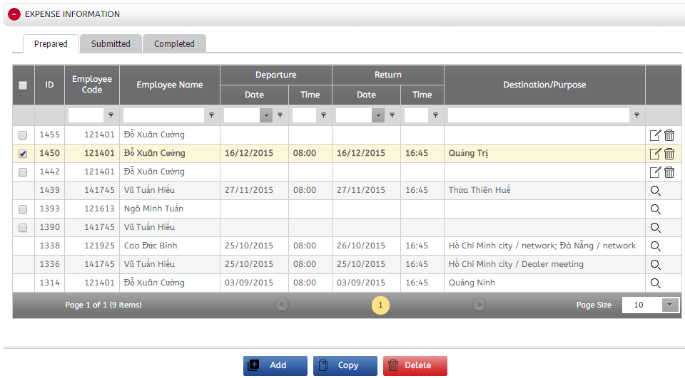

* Select employee(s) whose advanced request needed to copy as a template by ticking in the checkbox at the beginning of employee record in screen of ‘Choose Employees’ and click **[Copy]**



* ***Result:***
* After copied as template to other employee(s), new advanced request(s) will be cloned and showed in ‘EXPENSE INFORMATION’ in screen of ‘ONE DAY TRIP EXPENSE MANAGEMENT’.

***4.5: Delete expense request***

* ***Purpose:***
* Delete expense request of one day business trip
* ***Step to do:***
* Search for the last business trip in ‘SEARCH CONDITION’
* In ‘PAYMENT INFORMATION’, click dustbin icon to delete expense request that no need to use anymore.



* ***Result:***
* After deletion, advanced request(s) is/are deleted from system.

# 3. Over night trip – BT Approval

1. **Object**

* Employee or Timekeeper

1. **Purpose**

* Find history of advanced request of over night business trip
* View/ Create/ Modify advanced request of over night business trip

1. **Screen**

**Function access:** Over Night trip/ BT Approval

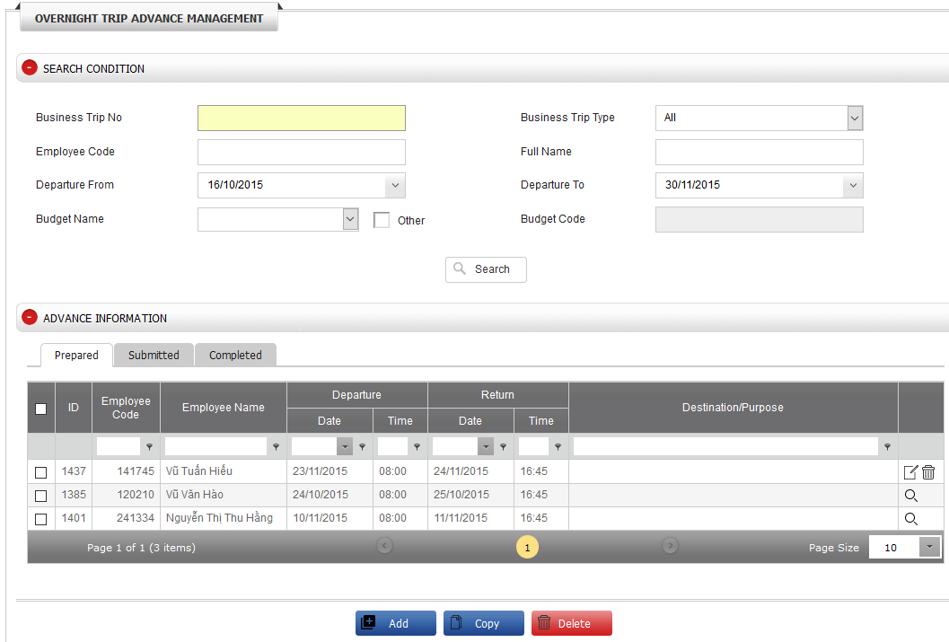

1. **Functions**

***4.1: Search***

* ***Purpose:***
* Find history of advanced request of over night business trip
* ***Step to do:***
* Input condition(s) in ‘SEARCH CONDITION’
* Business Trip No
* Business Trip Type
* Employee Code
* Full Name: full name of employee in advanced request
* Departure From: departure date
* Departure To: departure date
* Budget Name: Default list consists of budget code belongs to employee’s department only. In order to show all budget names of company’s budget code, just tick to Other check box
* Click **[Search]**
* ***Result:***
* All advanced requests of one day business trip satisfied with inputting conditions will be showed under ‘ADVANCE INFORMATION’
* The result will be showed in 3 tabs : Prepared, Submitted, Completed as the below statuses
  + Prepared: consist of all advanced requests which are newly created and not submitted yet
  + Submitted: consist of all advanced requests which are already submitted
  + Completed: consist of all advanced requests which are successfully created on finance system (Finance Dept. completely processed your request)

***4.2: Create new advanced request***

* ***Purpose:***
* Create new advanced request of over night business trip. Notice: Even if no advance on business trip, just input allowance amount with 0.
* Export information to correct template according to company policy: Business Trip Approval (Over nigth Trip)
* Submit to Finance Budget for checking Budget code purpose
* ***Step to do:***
* Click **[Add]**
* Input data to the screen of ‘Input BT Information’
  + Employee Code
  + Business Trip Type
  + Budget Name
  + Project Budget Code
* Click **[OK]** to go to detail screen.
* In ‘PURPOSE & DESTINATION’, input :
  + Departure Date
  + Return Date
  + Purpose: If your business trip is for a project or an event, you need to specify what project or event name. E.g. Project XXX or support project XXX of ABC department
* In ‘ADVANCE REQUEST’, input information at ‘**Common’** tab& ‘**Schedule’** tab

**‘Common’** tab (all allowance amount)

* Moving Time Allowance
* Click **[Add]** to input expense information and then click **[Save]** inputting data completed.
  + Destination: business trip province/ city
  + From Date: Department date
  + To: Return Date
  + Daily Allowance Request: meal allowance is auto calculated based on company policy
    - Times: Number of having breakfast, lunch, dinner
    - Unit: Allowance per day
    - Amount: Total allowance amount
  + Other Expense
  + Other Explaination: explain about other expenses
  + Remark

**Tab ‘Schedule’** (business trip schedule & GA request)

* Click **[Add]** to create new schedule and click **[Save]** after inputting data completed
  + Date: business trip date
  + Time: business trip time
  + Working Area
  + Task/ Remark
  + Transportation Fee
  + Request to GA: Air ticket / Training ticket / Car
* Click **[Save]** located at the bottom of screen to save all information
* Click **[Export Schedule]** or **[Export BT request]** to export Business trip schedule form or BT approval form (over night trip) form



* In ‘ATTACHMENT’, click **[Choose file]** to upload forms related to the business tripc
  + Business Trip Approval: Business trip Approval (over night trip) form
  + Business Trip Schedule
  + Others: other forms
* Click **[Submit]** to send to Finance Budget or click **[Cancel]** to cancel & close screen of OVER NIGHT TRIP ADVANCE MANAGEMENT’.
* ***Result:***
* All data on screen will be saved after clicking **[Save]** and submit to Finance Budget after clicking **[Submit]**
* Business Trip Number will be generated after clicking **[Save]**.

Business Trip Number is formatted as following:

* “Company branch code”S-“Employee code”-DDMMYY-XXX
* More details:
  + Company branch code: HQ (Head quarter), HN (Ha Noi Branch), HM (Ho Chi Minh Branch), TRN (Ha Noi Training Center), TSC (Toyota South Center)
  + Employee code: Employee code in current business trip
  + DDMMYY: Date generated after submitted successfully
  + XXX: sequence number increase automatically. Reset to 0 after over 999
* After submitted successfully, that advanced request will be showed at Submitted tab

***4.3: Modify advanced request***

* ***Purpose:***
* Modify advanced request of over night business trip
* Export to BT approval (Over night trip) form
* Submit to Finance Budget for checking Budget code purpose
* ***Step to do:***
* Search for the last business trip in ‘SEARCH CONDITION’
* In ‘ADVANCE INFORMATION’, click Edit icon of business trip that need to modify
* Correct business trip information an screen of ‘OVER NIGHT TRIP ADVANCE MANAGEMENT’
* In ‘ADVANCE REQUEST’, click Edit icon of record that need to modify and then click **[Save]** after completed modifying data.
  + Correct business trip information
* Click **[Save]** located at the bottom screen of OVER NIGHT TRIP ADVANCE MANAGEMENT’ to save all modified data
* Click [**Export Schedule**] or [**Export BT request**] to export Business trip schedule form or BT approval form (over night trip) form



* In ‘ATTACHMENT’, click **[Choose file]** to upload forms related to the business tripc
  + Business Trip Approval: Business trip approval (over night trip) from
  + Business Trip Schedule.
  + Others: other forms
* Click **[Submit]** to send to Finance Budget or click **[Cancel]** to cancel & close screen of ‘OVER NIGHT TRIP ADVANCE MANAGEMENT’.
* ***Result:***
* All data on screen will be saved after clicking **[Save]** and submit to Finance Budget after clicking **[Submit]**
* Business Trip Number will be generated after clicking **[Save]**:

Business Trip Number is formatted as following:

* “Company branch code”S-“Employee code”-DDMMYY-XXX
* More details:
  + Company branch code: HQ (Head quarter), HN (Ha Noi Branch), HM (Ho Chi Minh Branch), TRN (Ha Noi Training Center), TSC (Toyota South Center)
  + Employee code: Employee code in current business trip
  + DDMMYY: Date generated after submitted successfully
  + XXX: sequence number increase automatically. Reset to 0 after over 999
* After submitted successfully, that advanced request will be showed at Submitted tab.

***4.4: Copy business trip as template to other person(s)***

* ***Purpose:***
* Copy business trip as a template to other person(s)
* ***Step to do:***
* In sreen of ‘OVERNIGHT TRIP ADVANCE MANAGEMENT’, select an advanced request that needs to copy as a template by ticking in checkbox at the beginning of record and click **[Copy]** located at the bottom of screen



* Select employee(s) whose advanced request needed to copy as a template by ticking in the checkbox at the beginning of employee record in screen of ‘Choose Employees’ and click **[Copy]**



* ***Result:***
* After copied as template to other employee(s), new advanced request(s) will be cloned and showed in ‘ADVANCE INFORMATION’ in screen of ‘OVERNIGHT TRIP ADVANCE MANAGEMENT’

***4.5: Delete advanced request***

* ***Purpose:***
* Delete advanced request of over night business trip
* ***Step to do:***
* Search for the last business trip in ‘SEARCH CONDITION’
* In ‘ADVANCE INFORMATION’, click dustbin icon to delete expense request that no need to use anymore.
* ***Result:***
* After deletion, advanced request(s) is/are deleted from system.

# 4. Overnight trip – BT Expense Declaration

1. **Object**

* Employee or Timekeeper

1. **Purpose**

* Find history of expense request of over night business trip
* View/ Create/ Modify expense request of over night business trip

1. **Screen**

**Function access:** Over Night trip/ BT Expense Declaration

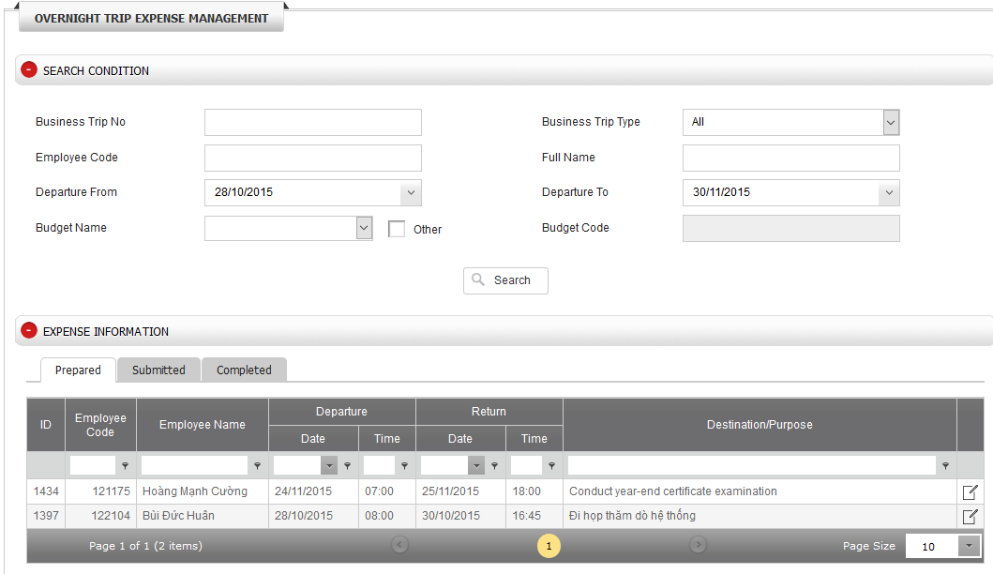

1. **Functions**

***4.1: Search***

* ***Purpose:***
* Find history of expense request of over night business trip.
* ***Step to do:***
* Input condition(s) in ‘SEARCH CONDITION’
* Business Trip No
* Business Trip Type
* Employee Code
* Full Name: full name of employee in expense request
* Departure From: departure date
* Departure To: departure date
* Budget Name: Default list consists of budget code belongs to employee’s department only. In order to show all budget names of company’s budget code, just tick to Other check box
  + Tick to Other box to show all company budget codes
* **Click [Search]**
* ***Result:***
* All expense requests of over night business trip satisfied with inputting conditions will be showed under ‘EXPENSE INFORMATION’
* The result will be showed in 3 tabs : Prepared, Submitted, Completed as the below statuses
  + Prepared: consist of all expense requests which are newly created and not submitted yet.
  + Submitted: consist of all expense requests which are already submitted
  + Completed: consist of all expense requests which are successfully created on finance system (Finance Dept. completely processed your request)

***4.2: Create new expense request***

* ***Purpose:***
* Create new expense request of over night business trip based on advanced requests
* Export information to correct template according to company policy: Business Trip Expense Declaration
* Submit to Finance Budget for checking Budget code purpose
* ***Step to do:***
* Find advanced requests that were created in system previously & click Edit icon



* Input information in screen of ‘OVER NIGHT TRIP EXPENSE MANAGEMENT’
* In ‘EXPENSE DECLARATION’, go to ‘Common’ tab and click **[Add]** to input expense information and click **[Save]** after inputting data completed.
  + Location: business trip province/city
  + Date: Business trip date
  + Daily Allowance:
    - Breakfast, Lunch, Dinner, Other: meal allowance is auto calculated based on company policy.
  + Hotel Expense
    - Amount: auto calculated based on company policy.
    - For over sea business trip: must input original currency (Actual Currency column), exchange rate (Exchange Rate column) to convert to USD. Default exchange rate will be auto get from system, it can be change based on actual rate.

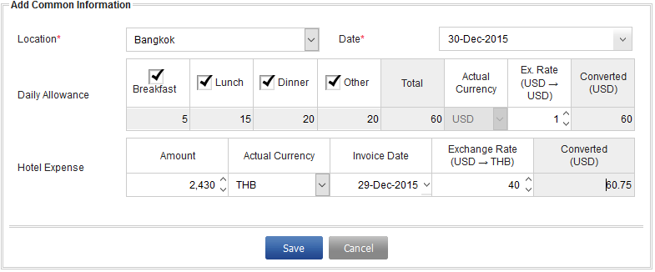

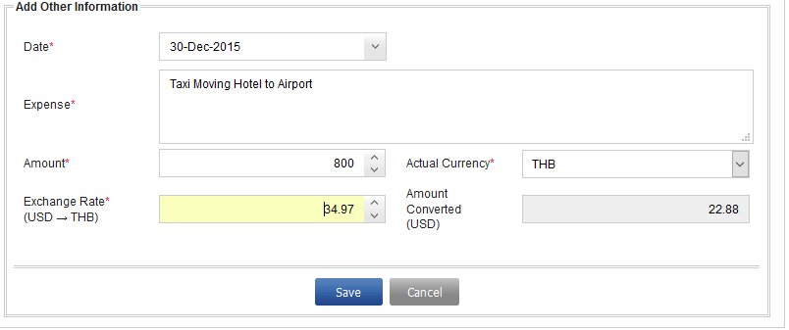

* Go to ‘Transportation & Other’ tab, click **[Add]** to input transportation information and then click **[Save]** after inputting data completed
  + Date: Departure date
  + Expense: describe expense name
  + Amount: paid amount
* Click **[Save]** located at the bottom screen of ‘OVER NIGHT TRIP EXPENSE MANAGEMENT’ to save all information
* Click [**Export BT request**] to export to Business Trip Expense Declaration form



* In ‘ATTACHMENT’, click **[Choose file]** to upload forms related to the business tripc
  + Business Trip Expense: Business trip expense declaration form
  + Others: other forms
* Click **[Submit]** to send to Finance Budget or click **[Cancel]** to cancel & close screen of ‘OVER NIGHT TRIP EXPENSE MANAGEMENT’.
* ***Result:***
* All data on screen will be saved after clicking **[Save]** and submit to Finance Budget after clicking **[Submit]**
* Business Trip Number of expense request will be the same as advanced request
* After submitted successfully, that advanced request will be showed at Submitted tab

***4.3: Modify expense request***

* ***Purpose:***
* Modify expense request of over night day business trip, that is not yet submitted to Finance
* Export to Business Trip Expense Declaration form after completed modifying data
* Submit to Finance Budget for checking Budget code purpose
* ***Step to do:***
* Search for the last business trip in ‘SEARCH CONDITION’
* In ‘EXPENSE INFORMATION’, click Edit icon of business trip that need to modify
* Correct business trip information an screen of ‘OVER NIGHT TRIP EXPENSE MANAGEMENT’
* In ‘PURPOSE & DESTINATION’, click Edit icon of record that need to modify and then click **[Save]** after completed modifying data.
  + Correct information
* In ‘EXPENSE DECLARATION, click Edit icon of record that need to modify and then click **[Save]** after completed modifying data.
  + Correct information
* Click **[Save]** located at the bottom screen of ‘OVER NIGHT TRIP EXPENSE MANAGEMENT’ to save all information
* Click **[Submit]** to send to Finance Budget or click **[Cancel]** to cancel & close screen of ‘OVER NIGHT TRIP EXPENSE MANAGEMENT’.
* ***Result:***
* All data on screen will be saved after clicking **[Save]** and submit to Finance Budget after clicking **[Submit]**
* After submitted successfully, that expense request will be showed at Submitted tab.

***4.4: Delete expense request***

* ***Purpose:***
* Delete expense request of over night business trip
* ***Step to do:***
* Search for the last business trip in ‘SEARCH CONDITION’
* In ‘EXPENSE INFORMATION’, click dustbin icon to delete expense request that no need to use anymore.
* ***Result:***
* After deletion, advanced request(s) is/are deleted from system.